Project Documentation Of
Soil Crop Recommendation System using Convolutional Autoencoder (CAE)
Abstract
This project develops a soil–crop recommendation system that predicts the most suitable crop for a given plot of land using soil nutrients and environmental conditions. The system is built around a Convolutional Autoencoder (CAE) that learns a compact latent representation of seven input features (N, P, K, temperature, humidity, pH, rainfall). A classification head on top of the encoder predicts one of 22 possible crops.
As a baseline, a Logistic Regression model is trained directly on standardized raw features. Both models are evaluated on the Crop Recommendation Dataset from Kaggle. The baseline achieves 97.58% accuracy, while the CAE-based classifier achieves 99.09% accuracy, with similarly strong precision, recall, and F1-scores. The project supports SDG 2 (Zero Hunger) by improving crop planning and SDG 12 (Responsible Consumption and Production) by promoting efficient and sustainable resource use.

1. Introduction
1.1 Background and Motivation
Crop selection is a critical decision for farmers, directly affecting yield, profitability, and environmental impact. Traditionally, crop choice is based on experience, local practice, or generic recommendations, which may not fully account for specific soil nutrient profiles and micro-climate conditions. Misaligned crops can result in:
- Low or unstable yields
- Excessive use of fertilizers and irrigation
- Higher production costs
- Soil degradation and environmental pollution
With the increasing availability of soil test reports and weather data, there is a strong opportunity to use Machine Learning (ML) to provide personalized, data-driven crop recommendations. This project aims to build such a system using modern deep learning and classical ML techniques.
1.2 Objectives
The main objectives of this project are:
- To build a Convolutional Autoencoder–based model that learns a latent representation of soil and weather features and uses it for crop classification.
- To implement a Logistic Regression baseline on raw standardized features for meaningful comparison.
- To evaluate both models on a public Crop Recommendation Dataset and compare their performance using accuracy, precision, recall, and F1-score.
- To analyze how the solution contributes to SDG 2 (Zero Hunger) and SDG 12 (Responsible Consumption and Production).
- To produce a reproducible codebase with training, evaluation, inference, and visualization scripts.

2. Relation to SDGs
2.1 SDG 2 – Zero Hunger
The system helps align crop choice with soil fertility and local climate, supporting:
- Improved yield and food availability
- Reduced risk of crop failure
- Better planning for smallholder farmers
By providing data-driven crop recommendations, the system can be integrated into advisory services to support more resilient and productive agriculture.
2.2 SDG 12 – Responsible Consumption and Production
By recommending crops that match existing soil nutrient levels and rainfall patterns, the system can:
- Reduce unnecessary fertilizer applications
- Optimize water use
- Minimize environmental contamination and resource wastage
This leads to more efficient and sustainable agricultural production.

3. Dataset
3.1 Source and Structure
- Dataset: Crop Recommendation Dataset
- Source: Kaggle
- Path in project: data/soil_crop/Crop_recommendation.csv
Each record corresponds to a combination of soil and climate conditions with a suitable crop label.
- Features (7):
  - N – Nitrogen content in soil
  - P – Phosphorus content
  - K – Potassium content
  - temperature – temperature in °C
  - humidity – relative humidity in %
  - ph – soil pH
  - rainfall – rainfall in mm
- Target:
  - label – crop name (22 different crops, e.g., rice, maize, jute, pigeonpeas, etc.)
3.2 Preprocessing
Preprocessing steps implemented in utils/data_loader.py:
- Train / Validation / Test Split
  - Train: ~70%
  - Validation: ~15%
  - Test: ~15%
  - Stratified by label to maintain class balance.

- Feature Scaling

  - All seven numeric features standardized using StandardScaler (mean 0, variance 1).
  - Scaling fitted on training data and applied to validation/test.
- Label Encoding
  - label column converted to integer classes via Label-Encoder.
- Reshaping for CAE
  - For the CAE, each standardized feature vector is reshaped from (7,) to (7, 1) to be treated as a 1D “sequence” for Conv1D layers.
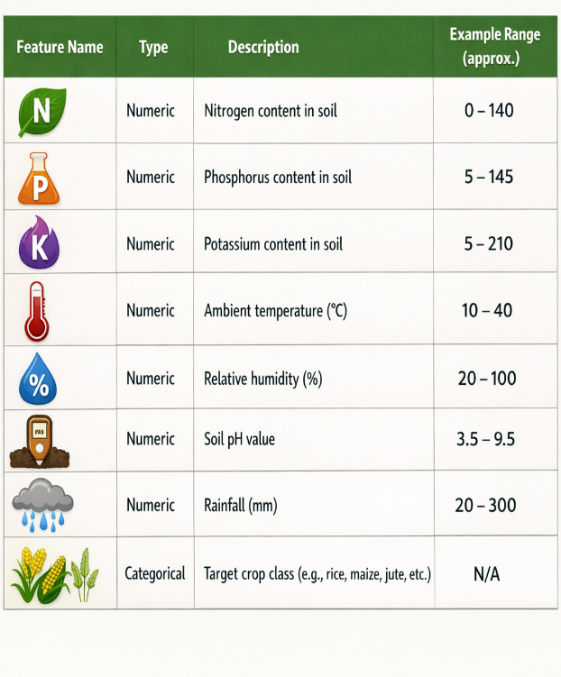
Figure 1: Summary of input features and target label used in the soil–crop recommendation system.

4. Methodology
4.1 System Overview
The system includes:
- Data pipeline – loading, splitting, preprocessing (scaling + encoding).
- Baseline Linear Model – Logistic Regression trained on raw standardized features.

- Main Deep Model – CAE-based classifier:
  - Stage 1: Autoencoder pretraining (unsupervised reconstruction)
  - Stage 2: Classifier training (supervised crop prediction)
- Evaluation & Visualization – metrics and plots.
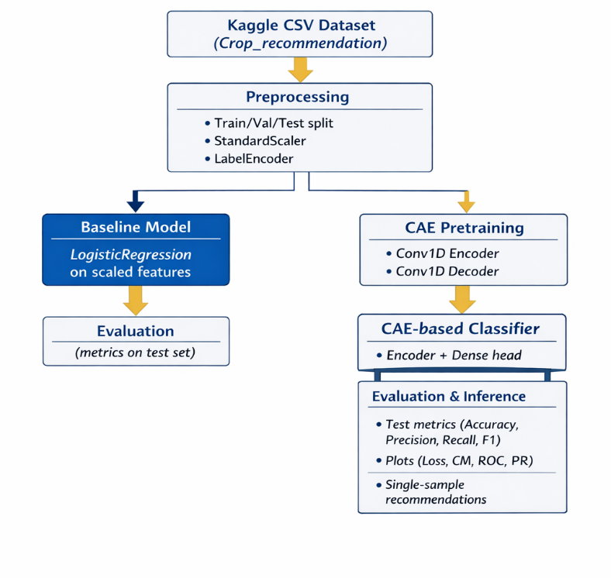
Figure 2: Overall system pipeline for the soil–crop recommendation system.

4.2 Baseline Model – Logistic Regression
- Implementation: baseline_logreg.py (scikit-learn LogisticRegression)
- Input: standardized features [N, P, K, temperature, humidity, ph, rainfall]
- Training Data: concatenation of train and validation splits
- Test Data: test split
- Hyperparameters:
  - max_iter = 500
  - solver = "lbfgs"
This provides a strong, simple baseline for multiclass classification on tabular data.

4.3 Main Model – Convolutional Autoencoder–Based Classifier
Implemented in model.py and used by train.py, evaluate.py, inference.py.
4.3.1 Encoder
- Input shape: (7, 1)
- Layers:
  - Conv1D(16, kernel_size=3, activation="relu", padding="same")
  - Conv1D(8, kernel_size=3, strides=2, activation="relu", padding="same")
  - Flatten() → latent vector
The encoder compresses the 7-dimensional input into a smaller latent space that captures important patterns in the soil–climate data.
4.3.2 Decoder (Autoencoder Part)
- Takes encoded feature map and attempts to reconstruct the original input sequence.
- Layers:
  - UpSampling1D(size=2)
  - Conv1D(16, kernel_size=3, activation="relu", padding="same")
  - Conv1D(1, kernel_size=3, activation="linear", padding="same")
  - Cropping/output adjustment to ensure final shape (7, 1)
- Loss: Mean Squared Error (MSE) between original and reconstructed input
- Purpose: Learn a robust representation of input conditions without labels (unsupervised).

4.3.3 Classifier Head
- Takes encoder output:
  - Dense(64, activation="relu")
  - Dense(22, activation="softmax") – 22 crop classes
- Loss: Sparse Categorical Cross-Entropy
- Optimizer: Adam
Two-stage training (implemented in train.py):
- Pretrain autoencoder for 20 epochs.
- Train classifier for 50 epochs, using the pretrained encoder.
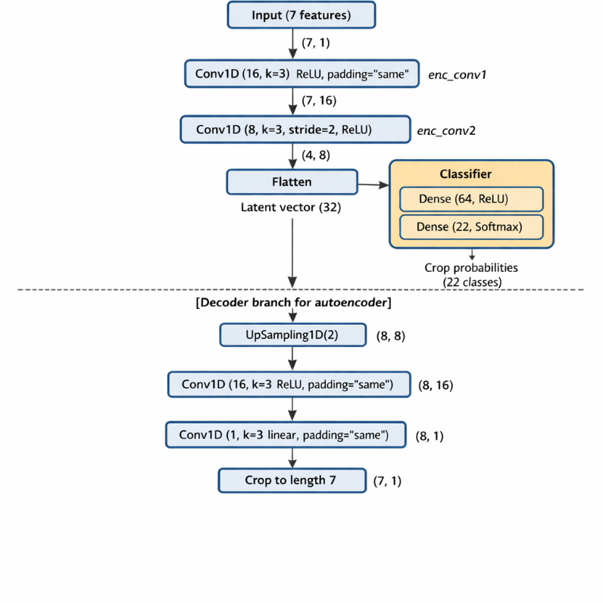
Figure 3: Convolutional Autoencoder (CAE)–based architecture for soil crop recommendation.

5. Experimental Setup
5.1 Data Splits
From utils/data_loader.py:
- Train: 1540 samples
- Validation: 330 samples
- Test: 330 samples
- Stratified by crop label.
5.2 Hyperparameters
CAE Pretraining:
- Epochs: 20
- Batch size: 32
- Loss: MSE
- Optimizer: Adam
Classifier (CAE-based):
- Epochs: 50
- Batch size: 32
- Loss: sparse categorical cross-entropy
- Optimizer: Adam
- Metrics: accuracy
Baseline Logistic Regression:
- max_iter = 500
- solver = "lbfgs"
5.3 Evaluation Metrics
For both baseline and main model:
- Accuracy
- Precision (weighted)
- Recall (weighted)
- F1-score (weighted)
- Classification report (per-class metrics)
For the main model, additional visualizations:
- Autoencoder training and validation loss curves
- Classifier training and validation loss/accuracy curves
- Confusion matrix
- Micro-averaged ROC and Precision–Recall curves

6. Results and Discussion
6.1 Baseline vs Main Model
Baseline – Logistic Regression (on raw standardized features)
(from baseline_logreg.py)
- Accuracy: 97.58%
- Precision (weighted): 97.64%
- Recall (weighted): 97.58%
- F1-score (weighted): 97.55%
Main Model – CAE-Based Classifier
(from evaluate.py)
- Accuracy: 99.09%
- Precision (weighted): 99.15%
- Recall (weighted): 99.09%
- F1-score (weighted): 99.09%
Comparison Table:
The Logistic Regression baseline already achieves very strong performance on this dataset. However, the CAE-based model further improves accuracy and F1-score by approximately 1.5 percentage points, demonstrating the benefit of learning a non-linear latent representation.
Table 1: Comparison of baseline Logistic Regression and CAE-based classifier on the test set, showing that while the baseline performs strongly, the CAE-based model further improves all metrics, especially accuracy and F1-score.
Model | Accuracy | Precision (weighted) | Recall (weighted) | F1-score (weighted)
Baseline – Logistic Regression | 97.58% | 97.64% | 97.58% | 97.55%
Main – CAE-based classifier | 99.09% | 99.15% | 99.09% | 99.09%

6.2 Visualizations (Figures)
All visualizations are given below:
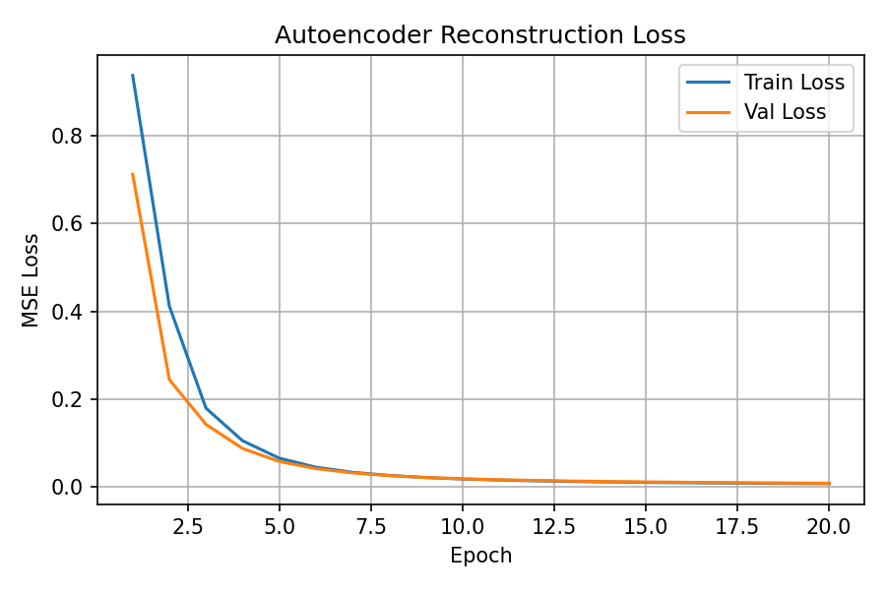
Figure 4: Autoencoder training and validation MSE loss versus epochs, showing both curves decreasing smoothly and converging, which indicates stable reconstruction learning and no obvious overfitting.
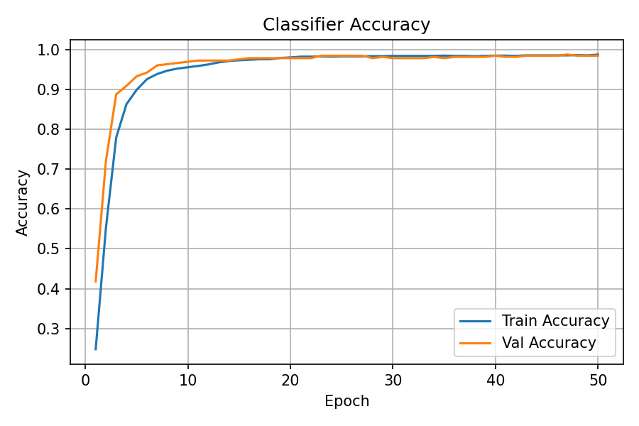
Figure 5: Classifier training and validation accuracy versus epochs, with validation accuracy approaching approximately 99%, indicating that the CAE-based classifier learns to predict crop classes very accurately without severe overfitting.
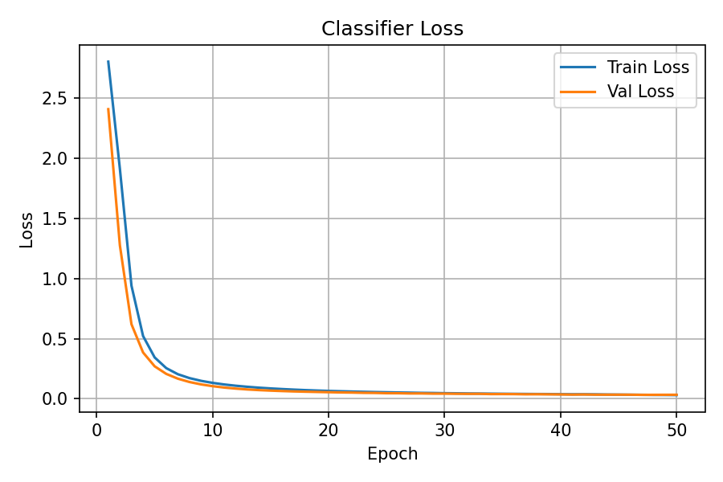
Figure 6: Classifier training and validation loss versus epochs, where validation loss steadily decreases alongside training loss, suggesting good optimization and generalization.
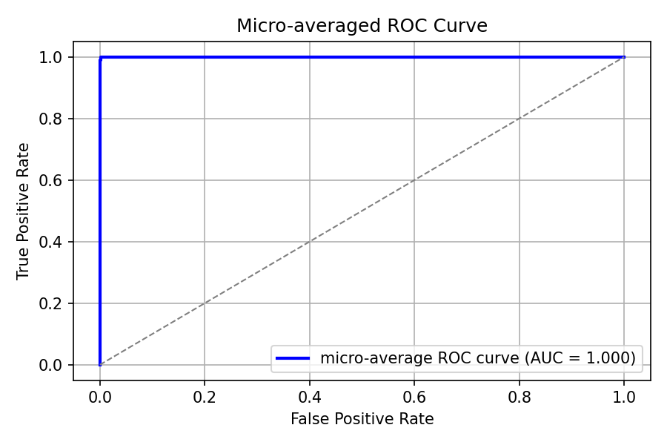
Figure 7: Micro-averaged ROC curve for the CAE-based classifier over all 22 crop classes, with a high area under the curve (AUC), demonstrating strong overall discriminative ability across classes.

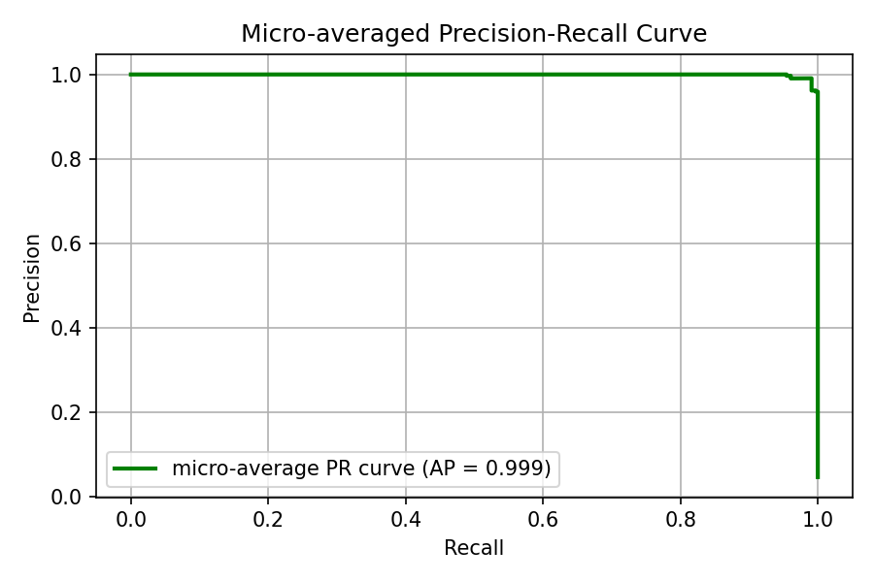
Figure 8: Micro-averaged Precision–Recall curve for the CAE-based classifier across all crop classes, with high average precision, indicating that the model maintains high precision even at high recall levels.

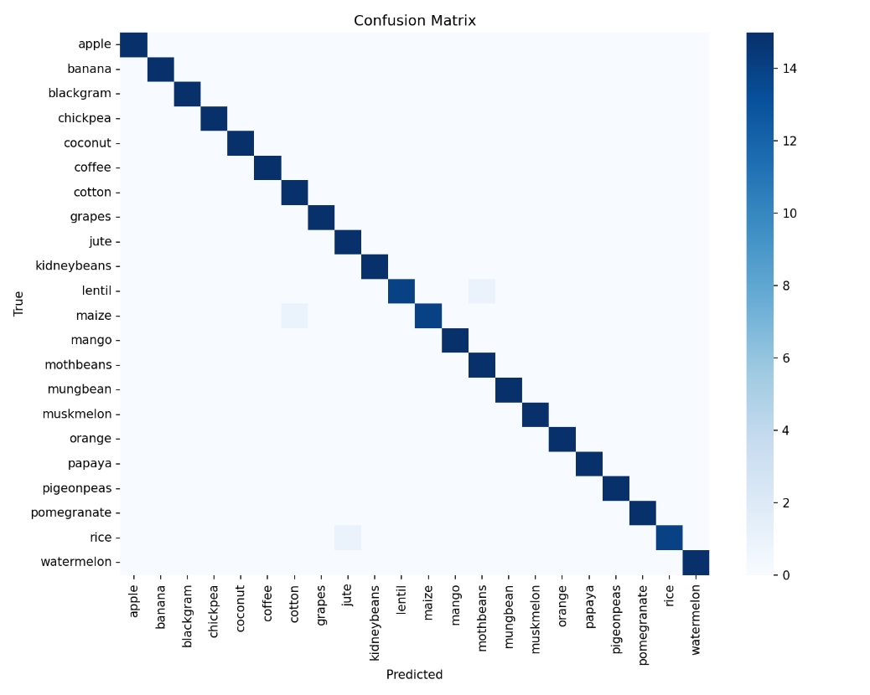
Figure 9: Confusion matrix of the CAE-based classifier on the test set, showing that most predictions lie on the diagonal, meaning nearly all crop classes are correctly classified, with only minor confusion between a few similar crops.

7. Technology Benefits
- Advanced Representation Learning:
The CAE encoder learns non-linear patterns from structured agricultural data, which can improve generalization compared to purely linear models.
- Modularity:
The encoder can be reused for other tasks (e.g., clustering soil conditions, anomaly detection on soil profiles).
- Reproducibility and Extensibility:
The codebase is organized into separate scripts (train.py, evaluate.py, baseline_logreg.py, inference.py, visualize_results.py) and utility modules (utils/), making it easy to reproduce experiments and extend the work.

8. Business and Practical Benefits
- Improved Crop Decision Support:
Farmers and advisors receive data-driven recommendations tailored to their specific soil and climate conditions, reducing guesswork.
- Cost and Resource Optimization:
Crop choices better aligned with soil fertility and rainfall can reduce fertilizer and irrigation costs, while maintaining or increasing yields.
- Scalability and Integration:
The model can be integrated into:
  - Mobile or web apps for farmers
  - Dashboards for agronomists or policy-makers
  - Advisory tools for government and NGOs
- Risk Mitigation:
Better crop–soil matching reduces the risk of crop failure, supporting economic stability for farming households.

9. Project Timeline (Actual / Approximate)
Table 2: Estimated project timeline showing major phases, key tasks, and approximate hours allocated from data preparation through modeling, evaluation, and final documentation/presentation.
Phase | Tasks | Approx. Hours
Data setup & exploration | Load data, inspect features, split train/val/test | 6–8
Baseline model implementation | Logistic Regression pipeline and evaluation | 4–6
CAE architecture + pretraining | Design, implement, and pretrain autoencoder | 8–10
Classifier training & tuning | Train classifier, monitor metrics, minor tuning | 8–10
Evaluation & visualization | Metrics, confusion matrix, ROC/PR, learning curves | 6–8
Documentation & presentation | Reports, slides, demo plan | 8–10

10. Tech Stack
- Language: Python 3.11
- Frameworks & Libraries:
  - TensorFlow / Keras
  - scikit-learn
  - NumPy, Pandas
  - Matplotlib, Seaborn
- Development Tools:
  - VS Code (primary)
  - Google Colab (early experimentation)
- Version Control:
  - Git + GitHub

